Final CA Mobile Development

Eduardo Kenji Zen Nakashima

Decisions made:

1 – Reuse all codes already studied in class and assignments in Mobile Devolopment
2 – Tried to use Phonegap HelloWorld template in order to ensure all plugins to work, as some of my colleagues had issues trying to install some plugins into the Framework7 template.
3 – Considerations:
All codes required to be reviewed to understanding level to be reused / changed.
4 – used as base the GPS lab
5 – following setup of functionalities in the following order to be able to progressive testing and final resource to save all data collected through the APIs:
Centre Map View: Extra feature, demanded research and lots of attempt and errors fixing. Main point is to centralise the map view where GPS or marker is pointing.
Map markers: Extra feature to get coordinates to also check country, city and current currency rate and weather.
Markers Info: Extra feature: Allow the map markers to update current values for country, city and currency, in order to emulate travels.
Coin conversion: required adaptation of coordinates in to the system to allows it to get current coordinates currency rates.
FSO: Data saving in persistent format into a test file.
Data info saved in text format, reading available in the console.
Reading treat to be seen in the map not available, once I couldn’t figure out why the array command push was not working.
Weather: Last data API to be treated, based on the lack of experience with it. Research to identify the easier to use is also required. I don’t have an idea of time required to find it.

  - screenshots of the Adobe cloud compiling process:
  - Creating a folder to synchronise with GitHub
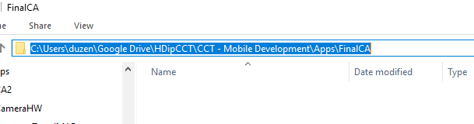

  - Creating new repository in GitHub Desktop

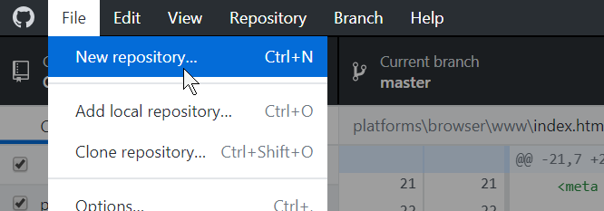

  - Linking directory in the repository on GitHub Desktop

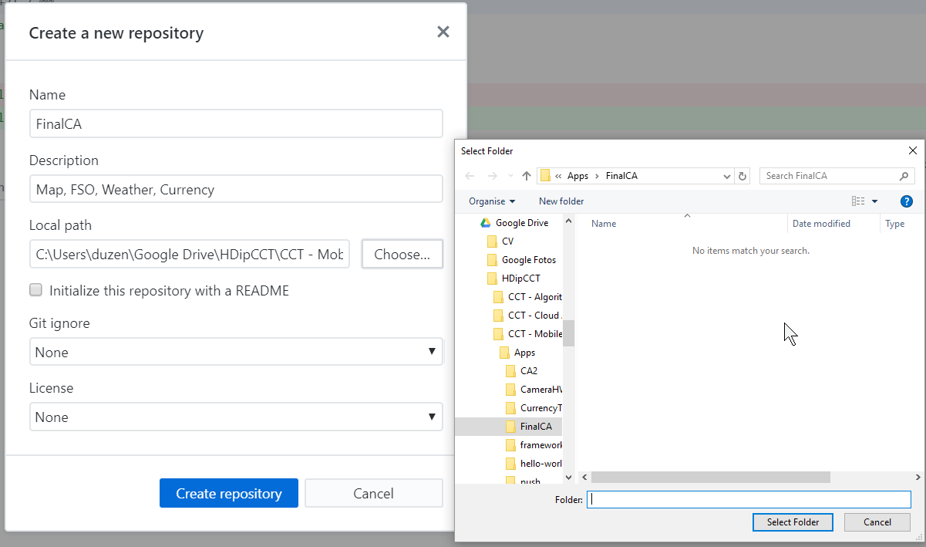

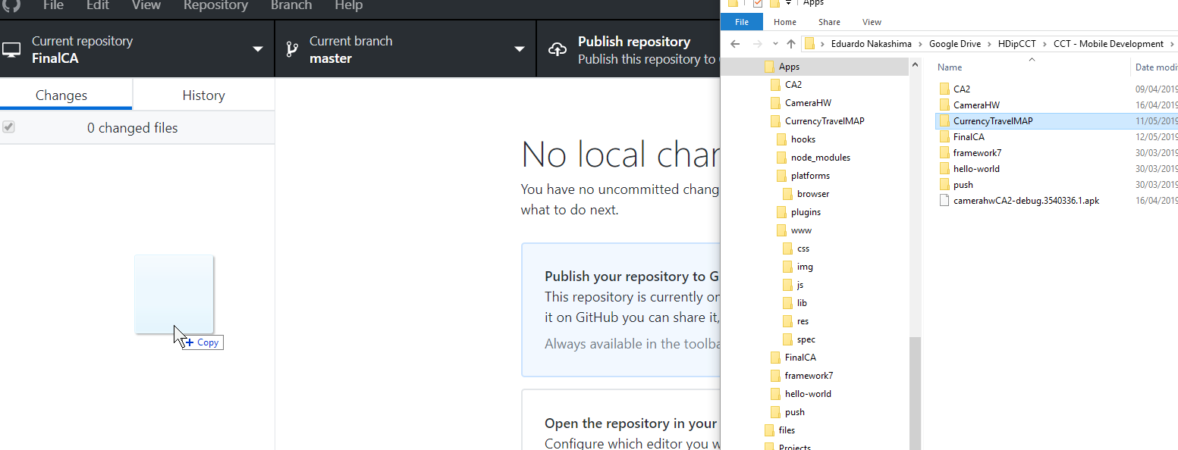
  - Copying files into the repository

  - Adding description required to the repository and commiting

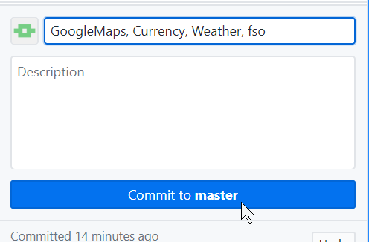

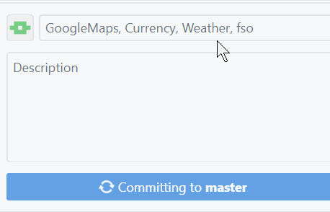

  - Publishing the repository

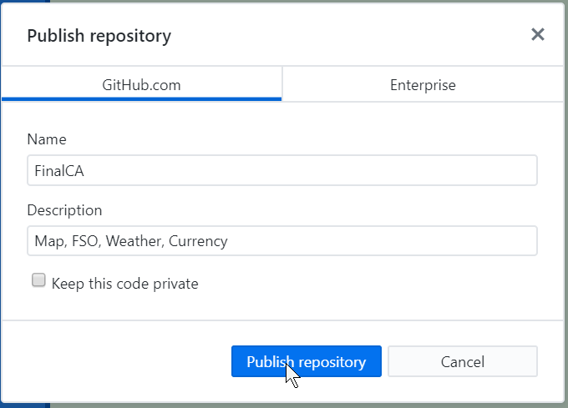

  - Copying url to phonegap build

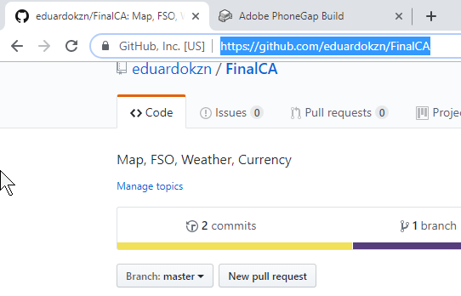

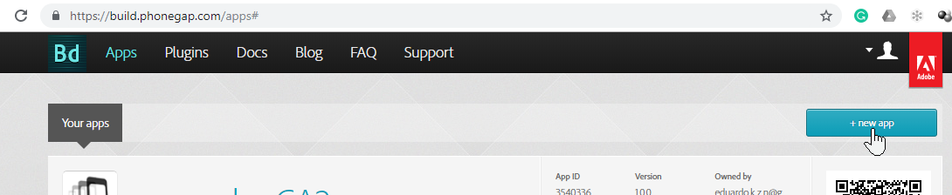

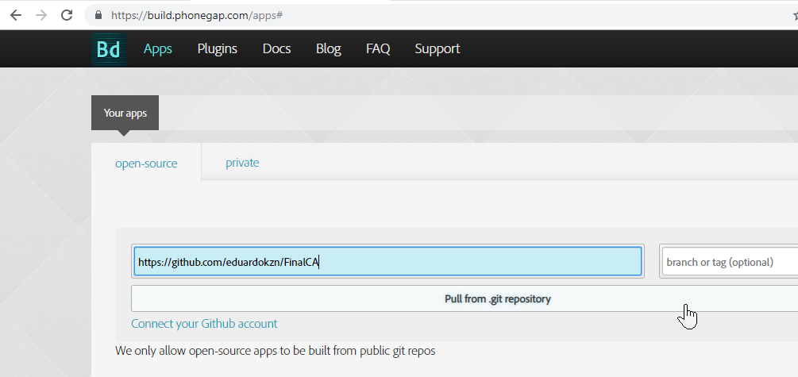

  - Building the app
  - vas

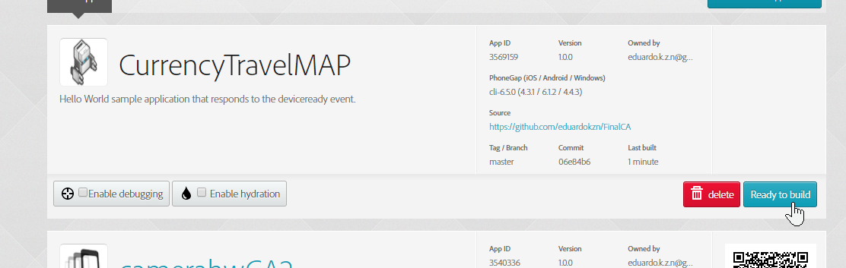

  - Saving the APK

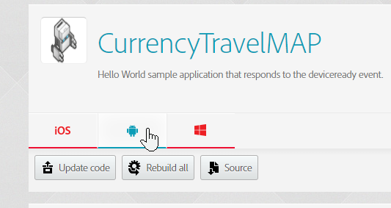

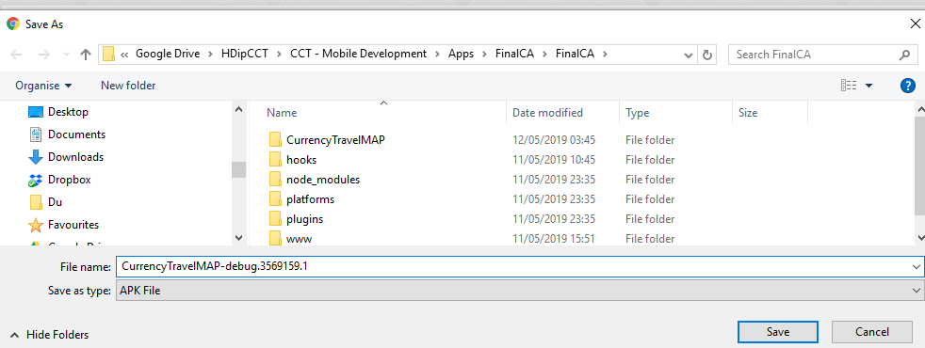

  - screenshots of your application in action:

